* **Survey of Fog Computing environment and its Simulators**

# Name: Saptarshi Shil (CSE, B.Tech)

Mail Id: 2105487@kiit.ac.in

Phone: 6909986056

# Introduction:

In this expeditious world of modern technology, data processing and communication have become integral to various aspects of our lives. With the rise of smart devices, Internet of Things (IOT) and increasing demand for real-time applications, the traditional cloud computing model faces some limitations, such as latency, bandwidth constraints, and privacy concerns. To cope up with these severe challenges, a new paradigm called "Fog Computing" has come into the scenario, which aims to bring computation and data storage closer to the edge of the network. Cloud computing has recast the way businesses and individuals’ access, store and manage data and applications. It is a technology that allows users to access computing resources, such as servers, storage, databases, software, and networking. instead of relying on local servers or personal computers, users can utilize a network of remote servers hosted on the internet to handle their computing needs. Cloud computing and Fog computing both are valuable paradigms. While cloud computing remains an excellent choice for many workloads, fog computing addresses specific challenges related to latency, bandwidth and privacy, making it a compelling option for edge-centric, real-time applications and industries where data processing proximity matters. Organizations should carefully evaluate their specific needs and consider the strengths and weaknesses of both approaches when choosing the most suitable computing model for their requirements. Fog computing, also known as edge computing, is a disseminate as well as decentralized computing architecture that extends cloud computing capabilities to the edge of the network, closer to the devices and data sources. The term "fog" was fabricated to represent a cloud that is closer to the ground, indicating its proximity to the edge devices **[1.10.1]**.

# 1.2. Principle of Fog Computing:

In conventional Cloud computing, data from IOT devices and sensors is transmitted to centralized data centers for processing and analysis. This process introduces latency, as the data must travel back and forth between the edge devices and the cloud servers, which can be problematic for real-time applications. Fog computing addresses this issue by placing intermediate computing nodes (fog nodes) in close proximity to the edge devices. These fog nodes can be smart gateways, routers, switches, or dedicated fog servers. They act as intermediaries between the edge devices and the centralized cloud, processing and analyzing data locally. Only relevant information or preprocessed data is sent to the cloud for further analysis or storage.

**1.3. Need of simulators in Fog Computing Environment:**

The need of simulators in fog computing environment are listed below:

## 1.3.1. SaaS Paas IaaS-

IaaS (infrastructure-as-a-service): Cloud computing infrastructure – servers, databases, etc. – that a cloud provider manages. Companies can build their own applications on IaaS instead of maintaining their applications' backends themselves.

PaaS (platform-as-a-service): PaaS includes development tools, infrastructure, and other support for building applications. SaaS (software-as-a-service): Fully built cloud applications **[1.10.22]**.

## 1.3.2. Railway System-

In India, railway system travelling is important for education, career of for vacation with family and railway plays a vital role and a cloud-based analytics system can help in reducing unexpected downtime, and enhancing productivity, resulting in improved outcomes. It can also boost efficiency in billing operations **[1.10.22]**.

## 1.3.3. Traffic System-

Traffic issue is very prominent in several areas of our country. Every year, approximately 1.5 lakh people dies on India roads. In this scenario, various traffic signals, surveillance cameras, and sensors are deploying across the city to collect real-time traffic data to make transportation efficient **[1.10.22]**.

## 1.3.4. Cost-Effectiveness-

In scenario of cost-effectiveness researchers can use a fog computing simulator like Fog Sim or iFogSim to create a virtual model of the smart city's traffic management system. The simulator can represent fog nodes, traffic sensors, cameras, and vehicles to emulate real-world interactions **[1.10.22]**.

## 1.3.5. Current Scenario-

In the current scenario, simulators can reproduce specific situations like severe weather conditions, accidents, or unexpected roadblocks to assess the system's robustness and ensure it can handle adverse situations effectively **[1.10.22]**.

## 1.3.6. Education and Training-

For education and training, students and professionals can use the simulator to learn about fog computing and smart city technologies, and gain experience **[1.10.22]**.

## 1.3.7. Standardization and benchmarking-

For standardization by using the simulator, researchers can establish standardized benchmarks for evaluating the performance of different smart traffic management approaches, enabling fair comparisons and driving advancements in the field **[1.10.22]**.

## 1.3.8. Rapid Prototyping-

In case of rapid prototyping developers can quickly prototype and validate new algorithms for traffic prediction, congestion control, or emergency response in the virtual fog computing environment. These speeds up the development process and facilitates faster innovative of traffic management solutions **[1.10.22].**

# 1.4 Challenges:

The fog environment is not free from challenges , some of the challenges are -

## 1.4.1. Practicality and Correctness-

In practical sense we need accuracy in model of real time scenarios to get the meaningful cognizance. Considering the varying conditions of network, we have to go for a realistic approach of simulation in the complex and dynamically interacting environment **[1.10.2][1.10.3]**.

## 1.4.2. Security and Privacy-

when data processing tasks are shared across a network of different computers, creating a single supercomputer (distributed network) it challenges the privacy of user. Therefore, simulators should focus on access and encryption **[1.10.2][1.10.3]**.

## 1.4.3. Algorithm Validation-

It basically involves several valid protocols where task offloading, data distribution etc. involves in standardized manner. In simulated environment we need careful considerations to ensure the accuracy of the result **[1.10.2][1.10.3].**

## 1.4.4. Motility and Variability-

Here in this scenario of computing devices like IOT (Internet of Things) devices became ambulant which leads to frequent changes in their network connectivity. In this handling of dynamic topologies can be considered tough in consideration of simulators **[1.10.2][1.10.3]**.

## 1.4.5. Diversity-

Environments like Fog computing environments are very much diverse as well as heterogeneous, which includes various operating systems as well as several protocols. So, to ensure this we need compatibility among the different variants of simulators which can be turned as a challenge **[1.10.2][1.10.3]** .

## 1.4.6. Flexibility-

In this Fog computing environment, the aim is to support the IOT devices and upliftment of the fog nodes which is distributed variably. So, such simulating environments can become computationally intensive and requires a lot of updating to sort the varying section of elements **[1.10.2][1.10.3]**.

## 1.4.7. Energy Imitations-

For any computing environment, energy utilization is a challenging factor. For better estimation of performance, we have to simulate the accurate energy implications to raise the energy idiom **[1.10.2][1.10.3]**.

## 1.4.8. Resource Imitations-

In this to design an accurate resource model including bandwidth, storage etc. have become significant for relevant simulation repercussion. To make it relevantly optimized we may feel some challenging obstruction in this Fog computing environment **[1.10.2][1.10.3]**.

# 1.5 Commercial Available Simulators for Fog Computing Environment

## In this section we have identified some fog computing simulators named as - CloudSim, Cloud Analyst, Green Cloud, MDCSim, iCanCloud, NetworkCloud Sim, EMU Sim, GROUND Sim, DCSim, MR-CLOUD SIM, SMART SIM, SIM IC. Description of all the simulators are listed below :

## 1.5.1 CloudSim : [ <https://www.geeksforgeeks.org/what-is-cloudsim/amp/>]

CloudSim is an open-source cloud computing simulation toolkit that enables researchers and developers to model, simulate, and experiment with cloud computing environments. It provides a platform for evaluating the performance, scalability, and resource management strategies in cloud systems **[1.10.8]**.

**[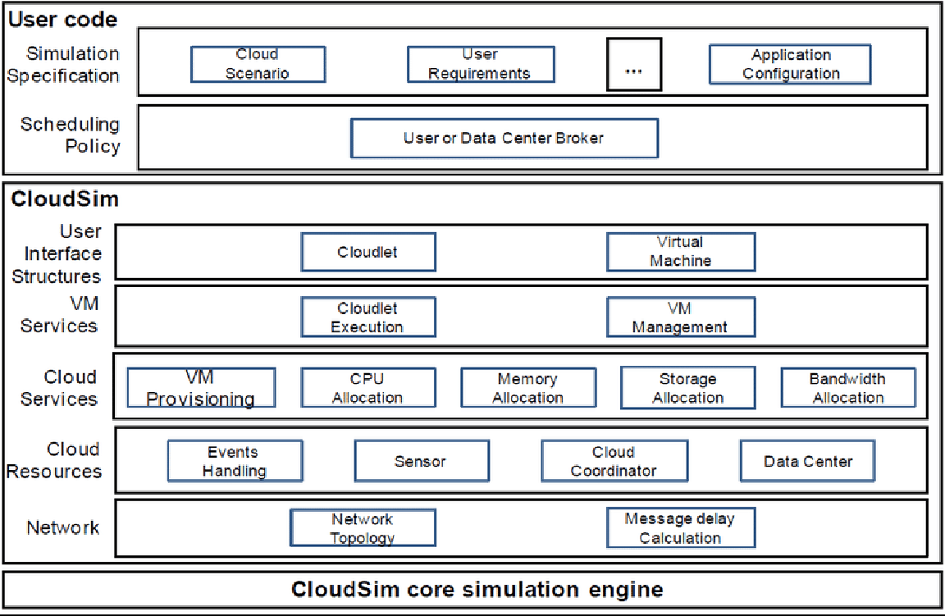](https://www.researchgate.net/figure/Architecture-of-CloudSim-The-CloudSim-simulator-is-a-layered-architecture-The-different_fig2_321348087)**

[https://www.researchgate.net/figure/Architecture-of-CloudSim-The-CloudSimsimulator-is-a-layered-architecture-The-different_fig2_321348087](https://www.researchgate.net/figure/Architecture-of-CloudSim-The-CloudSim-simulator-is-a-layered-architecture-The-different_fig2_321348087)

**Figure 1**

## 1.5.1.1 Advantages of CloudSim:

Some of the advantages of CloudSim are listed below :

* **Open source and free of cost**: Open source and free of cost favors researchers/developers working in the field, making it accessible to a broader audience without financial constraints **[1.10.8]**.
* **Easy to download and set-up**: Easy to download and set-up simplifies the initial setup process, allowing users to start experimenting quickly **[1.10.8]**.
* **Generalized and extensible**: Generalized and extensible CloudSim supports modeling and experimentation across various cloud computing scenarios, making it versatile for different research and development purposes **[1.10.8]**.
* **Low hardware requirements**: Low hardware requirements, makes it suitable for a wide range of devices **[1.10.8]**.

## 1.5.1.2 Disadvantages of CloudSim:

Some of the disadvantages of CloudSim are listed below :

* **Steep learning curve**: CloudSim requires significant effort to become proficient, potentially hindering adoption for newcomers in cloud computing or simulation software **[1.10.8]**.
* **Limited support for some cloud services**: Not all specific cloud services or environments are supported, which may restrict its utility for users with specialized requirements **[1.10.8]**.
* **Resource-intensive**: Running simulations with CloudSim demands substantial processing power and memory, making it challenging for users with limited computing resources or large-scale simulation needs **[1.10.8]**.
* **Limited visualization capabilities**: CloudSim's visualization features are limited, which can hinder users' understanding of complex simulation results and handling large data outputs **[1.10.8]**.

## 1.5.2 Cloud Analyst :

## [<https://www.researchgate.net/figure/The-Cloud-Analyst-Simulator_fig2_271155413>]

## Cloud Analyst is a tool that helps developers to simulate large-scale Cloud applications with the purpose of understanding performance of such applications under various deployment configurations **[1.10.10]**

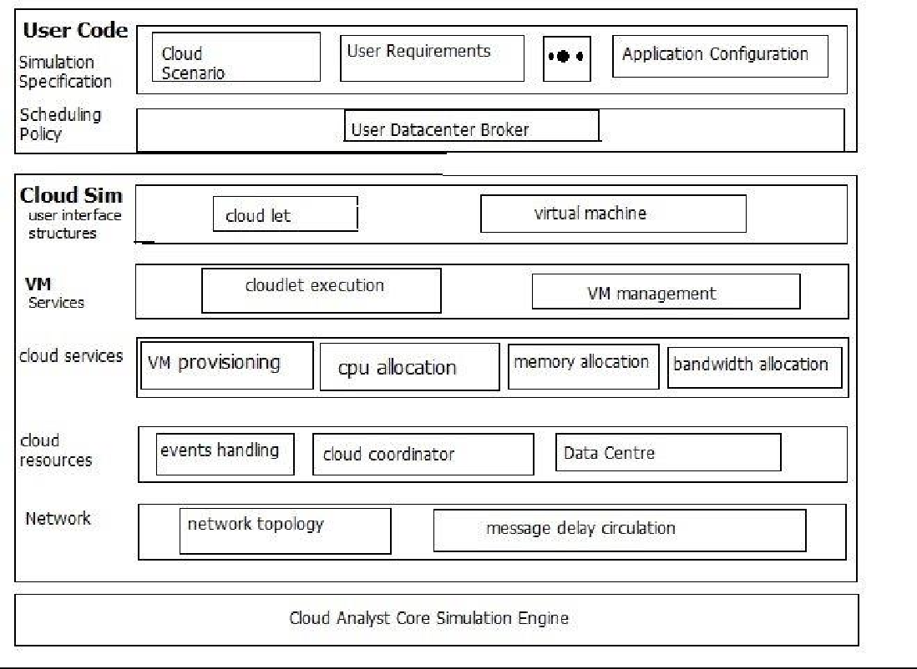

<https://www.researchgate.net/figure/The-Cloud-Analyst-Architecture_fig8_304617186>

**Figure 2**

**1.5.2.1 Advantages of Cloud Analyst :**

Some of the advantages of Cloud Analyst are listed below :

## **Flexibility:** Cloud Analyst offers high flexibility, allowing users to customize and model diverse cloud computing infrastructures, applications, performance metrics, and simulation scenarios to suit their specific research or operational needs **[1.10.10].**

* **Cost-effective**: Being an open-source tool, Cloud Analyst is freely available, making it an economical choice for researchers, educators, and practitioners who want to simulate cloud computing systems without financial constraints **[1.10.10]**.
* **Scalability**: Cloud Analyst is designed to handle large-scale cloud computing infrastructures and applications. This capability enables users to simulate complex scenarios and assess the performance of various cloud configurations and deployment strategies effectively **[1.10.10]**.
* **Energy efficiency**: Cloud Analyst incorporates energy consumption and carbon footprint modelling capabilities. This allows users to analyse the environmental impact of their cloud computing systems and identify opportunities for enhancing energy efficiency and reducing carbon emissions **[1.10.10]**.

## 1.5.2.2 Disadvantages of Cloud Analyst :

Some of the disadvantages of Cloud Analyst are listed below :

* **Complexity**: Cloud Analyst can be challenging to use, particularly for users unfamiliar with cloud computing concepts and technologies. It demands technical knowledge and expertise to set up and execute simulations effectively **[1.10.10]**.
* **Resource-intensive**: Cloud Analyst simulations require substantial computing power and memory resources, potentially limiting its usage to organizations or individuals with access to high-performance computing resources **[1.10.10]**.
* **Limited scope**: Despite being customizable, Cloud Analyst may have limitations in certain areas. It might not support specific cloud computing technologies or deployment scenarios, which could restrict its applicability for some users **[1.10.10]**.
* **Lack of real-world data**: Cloud Analyst relies on simulated data, and its outputs may not perfectly mirror real-world cloud computing scenarios. As a result, its effectiveness in evaluating real-world cloud system performance could be limited **[1.10.10]**.

**1.5.3 Green Cloud :** [<https://greencloud.gforge.uni.lu/>]

Green Cloud is a sophisticated packet-level simulator for energy-aware cloud computing data centers with a focus on cloud communications **[1.10.11]**.

**1.5.3.1. Advantages of Green Cloud:**

Some of the advantages of Green Cloud are listed below :

* **Energy efficiency**: Energy efficiency users to analyse the energy consumption and carbon footprint of their cloud setups and discover opportunities for energy savings **[1.10.11]**.
* **Customization**: Green Cloud offers high flexibility, allowing users to customize and model various energy-efficient cloud computing infrastructures and applications. Additionally, it can incorporate different energy-related performance metrics and simulation scenarios to suit specific research or operational needs **[1.10.11]**.
* **Scalability**: Green Cloud is optimized to handle large-scale energy-efficient cloud computing infrastructures and applications. Users can simulate complex scenarios and assess the performance of different energy-efficient cloud configurations and deployment strategies effectively **[1.10.11]**.
* **Educational value**: Green Cloud serves as an educational tool for teaching students about energy- efficient cloud computing concepts and technologies. It also introduces them to simulation-based research methodologies, enhancing their understanding of energy efficiency in cloud computing **[1.10.11]**.

## 1.5.3.2 Disadvantages of Green Cloud:

Some of the disadvantages of Green Cloud are listed below:

* **Complexity**: Green Cloud’s complexity may pose challenges for users unfamiliar with energy- efficient cloud computing concepts and technologies. Effective usage requires technical knowledge and expertise to set up and conduct simulations **[1.10.11]**.
* **Resource-intensive**: Green Cloud simulations demand substantial computing power and memory resources, potentially restricting its usage to organizations or individuals with access to high- performance computing resources **[1.10.11]**.
* **Limited scope**: Despite being highly customizable, Green Cloud might have limitations in certain areas. It may not support specific energy-efficient cloud computing technologies or deployment scenarios, which could narrow its applicability for some users **[1.10.11]**.
* **Lack of real-world data**: Green Cloud relies on simulated data, and its outputs may not perfectly represent real-world energy-efficient cloud computing scenarios. Consequently, its effectiveness in evaluating the performance of real-world energy-efficient cloud computing systems may be limited **[1.10.11]**.

## 1.5.4 MDCSim

## [<https://www.researchgate.net/figure/Overview-of-MDCsim-Simulator24_fig1_261436186>]

MDCSim is an event driven simulation— similarly to CloudSim. The main drawback of MDCSim is that it is not available for public download since it is built on , a commercial product **[1.10.12]**.

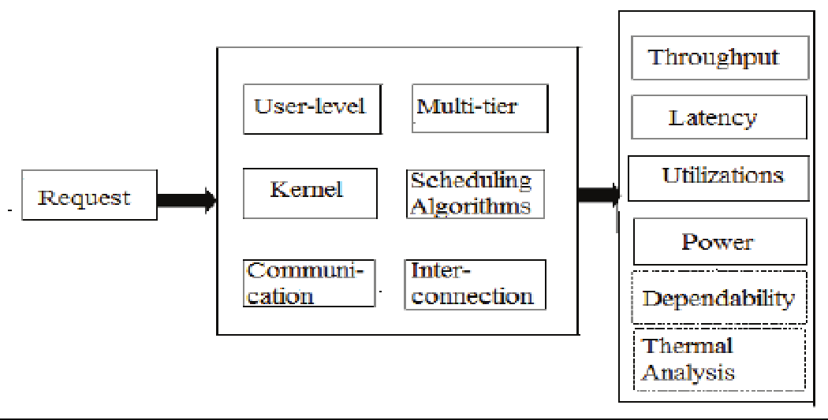

<https://www.researchgate.net/figure/Overview-of-MDCsim-Simulator24_fig1_261436186>

**Figure 3**

**1.5.4.1 Advantages of MDCSim**

Some of the advantages of MDCSim are listed below :

* **MEC-focused**: MDCSim is specifically designed to model and simulate Mobile Edge Computing (MEC) systems. This specialized focus allows users to thoroughly assess the performance of MEC systems and identify areas for improvement **[1.10.12]**.
* **Customization**: MDCSim offers high flexibility, enabling users to customize and model various MEC infrastructures and applications. Additionally, it can incorporate different performance metrics and simulation scenarios to cater to specific research or operational needs **[1.10.12]**.
* **Scalability**: MDCSim is optimized to handle large-scale MEC infrastructures and applications. Users can simulate complex scenarios and evaluate the performance of different MEC configurations and deployment strategies effectively **[1.10.12]**.
* **Educational value**: MDCSim serves as an educational tool for teaching students about Mobile Edge Computing concepts and technologies. It also introduces them to simulation-based research methodologies, enhancing their understanding of MEC systems **[1.10.12]**.

## 1.5.4.2 Disadvantages of MDCSim:

Some of the disadvantages of MDCSim are listed below:

* **Complexity**: MDCSim's complexity may pose challenges for users who lack familiarity with MEC concepts and technologies. Effectively using the tool requires technical knowledge and expertise to set up and conduct simulations **[1.10.12]**.
* **Resource-intensive**: MDCSim simulations demand substantial computing power and memory resources, potentially restricting its usage to organizations or individuals with access to high- performance computing resources **[1.10.12]**.
* **Limited scope**: Despite being highly customizable, MDCSim might have limitations in certain areas. It may not support specific MEC technologies or deployment scenarios, which could narrow its applicability for some users **[1.10.12]**.
* **Lack of real-world data**: MDCSim relies on simulated data, and its outputs may not perfectly represent real-world MEC scenarios. Consequently, its effectiveness in evaluating the performance of real-world MEC systems may be limited **[1.10.12]**.

**1.5.5 iCanCloud**

[<https://omnetpp.org/download-items/iCanCloud.html>]

iCanCloud is a simulation platform aimed at modeling and simulating cloud computing systems, which is targeted to those users who deal closely with those kinds of systems **[1.10.13]**.

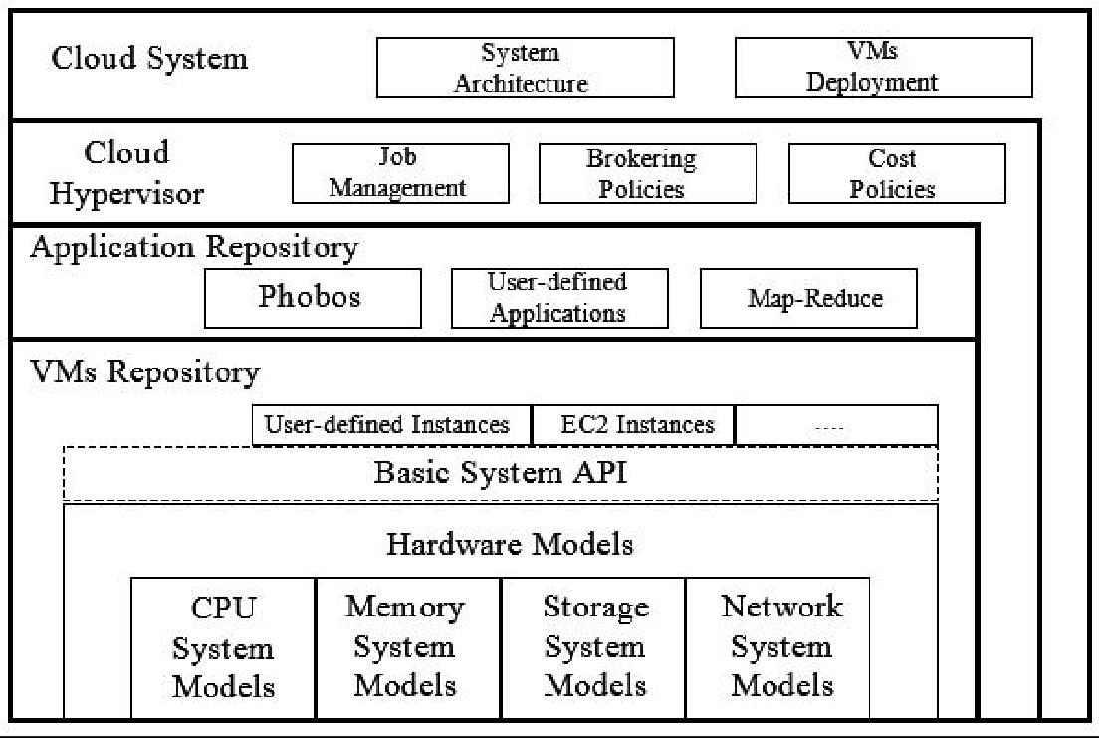

<https://www.researchgate.net/figure/Architecture-of-iCanCloud_fig4_301241369>

**Figure 4**

**1.5.5.1 Advantages of iCanCloud:**

Some of the advantages of iCanCloud are listed below :

* **Customization**: iCanCloud offers extensive customization options, allowing users to model diverse cloud computing configurations and scenarios. This flexibility enables experimentation with various hardware, software setups, network topologies, and resource allocation policies **[1.10.13]**.
* **Scalability**: iCanCloud is specifically designed to handle large-scale cloud computing infrastructures, making it suitable for evaluating the performance and scalability of cloud solutions under realistic conditions **[1.10.13]**.
* **Cost-effective**: As an open-source tool, iCanCloud is freely accessible, making it a cost-effective solution for researchers, developers, and educators to conduct experiments and research in the field of cloud computing **[1.10.13]**.
* **User-friendly interface**: iCanCloud provides a user-friendly interface that simplifies the setup and execution of simulations. The tool's detailed visualizations of simulation results make it easy for users to analyze and interpret the data effectively **[1.10.13].**

## 1.5.5.2 Disadvantages of iCanCloud:

Some of the disadvantages of iCanCloud are listed below :

* **Limited scope**: iCanCloud's primary focus is on simulating cloud computing infrastructures, which means it may not support other types of distributed computing systems, potentially limiting its applicability in certain scenarios **[1.10.13]**.
* **Complexity**: iCanCloud's complexity may pose challenges for users who lack familiarity with cloud computing concepts and technologies. Effective usage requires technical knowledge and expertise to set up and conduct simulations **[1.10.13]**.
* **Resource-intensive**: iCanCloud simulations demand substantial computing power and memory resources, potentially restricting its usage to organizations or individuals with access to high- performance computing resources **[1.10.13]**.
* **Lack of real-world data**: iCanCloud relies on simulated data, and its outputs may not perfectly represent real-world cloud computing scenarios. Consequently, its effectiveness in evaluating the performance of real-world cloud computing systems may be limited **[1.10.13]**.

## 1.5.6. NetworkCloudSim [

## <https://ieeexplore.ieee.org/document/6123487>]

NetworkCloudSim allows researchers to model large-scale distributed application such as message passing applications that requires tasks communication and sharing data between each other **[1.10.14]**.

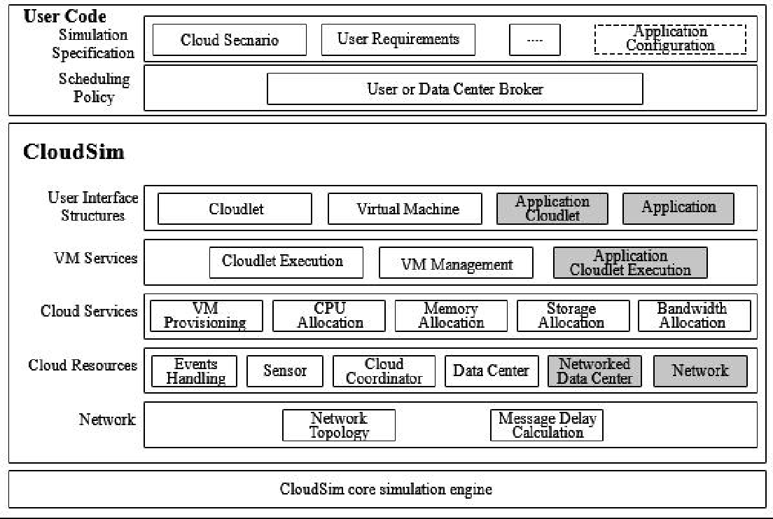

<https://www.researchgate.net/figure/Architecture-of-CloudSim-The-CloudSim-simulator-is-a-layered-architecture-The-different_fig2_321348087>

**Figure 5**

**1.5.6.1 Advantages of NetworkCloudSim:**

Some of the advantages of NetworkCloudSim are listed below:

* **Realistic network simulation**: NetworkCloudSim provides accurate simulation of network components (routers, switches, data centers) in cloud computing, enhancing evaluation under realistic network conditions **[1.10.14]**.
* **Customization**: Users can extensively customize NetworkCloudSim to model different cloud computing configurations and scenarios, allowing experimentation with various hardware, software setups, network topologies, and resource allocation policies **[1.10.14]**.
* **Scalability**: NetworkCloudSim is designed to handle large-scale cloud computing infrastructures, enabling the assessment of cloud solutions' performance and scalability under realistic and demanding conditions **[1.10.14]**.
* **Cost-effective**: As an open-source tool, NetworkCloudSim is freely available, making it a cost- effective option for researchers, developers, and educators to explore cloud computing solutions without financial barriers **[1.10.14]**.

## 1.5.6.2 Disadvantages of NetworkCloudSim:

Some of the disadvantages of NetworkCloudSim are listed below:

**Complexity:** NetworkCloudSim may be challenging to use, particularly for users unfamiliar with cloud computing concepts and technologies. Effective usage requires technical knowledge and expertise to set up and conduct simulations effectively **[1.10.14]**.

**Scalability:** Emusim allows for scalability testing, making it possible to test the performance of an application on a larger scale without the need for additional physical hardware **[1.10.14]**.

* .
* **Resource-intensive:** NetworkCloudSim simulations demand substantial computing power and memory resources, potentially restricting its usage to organizations or individuals with access to high- performance computing resources **[1.10.14].**
* **Limited support for real-world data:** NetworkCloudSim relies on simulated data, and its outputs may not perfectly mirror real-world cloud computing scenarios. Consequently, its effectiveness in evaluating the performance of real-world cloud computing systems may be limited **[1.10.14]**.
* **Latency and Network Dependence:** Cloud-based mixed reality simulations may introduce latency due to data transmission over the internet.

**1.5.7 EMUSIM [<https://www.researchgate.net/publication/236270590_EMUSIM_An_Integrated_Emulation_and_Simulation_Environment_for_Modeling_Evaluation_and_Validation_of_Performance_of_Cloud_Computing_Applications>]**

(An Integrated Emulation and Simulation Environment for Modeling, Evaluation, and Validation of Performance of Cloud Computing Applications)Emusim is a software tool that allows developers to simulate the execution of applications on a range of computer architectures **[1.10.15]**.

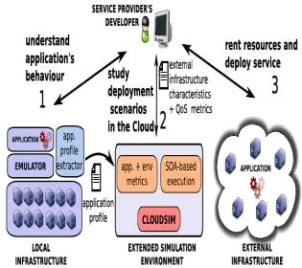 <https://startertutorials.com/blog/wp-content/uploads/2015/11/emusim-architecture.jpg>

**Figure 6**

## 1.5.7.1 Advantages of EMU SIM:

Some of the advantages of EMU SIM are listed below :

* **Cost-effective:** Emusim can save costs as it eliminates the need for physical hardware for testing applications on different architectures **[1.10.15]**.
* **Time-saving:** Emusim can accelerate the development process by enabling quick and efficient testing on various architectures without the need to switch between different physical machines **[1.10.15]**.
* **Error Detection:** Emusim can help developers identify and fix errors that may not be easily detected in physical testing environments **[1.10.15]**.

## 1.5.7.2 Disadvantages of EMU SIM:

Some of the disadvantages of EMU SIM are listed below:

* **Limited accuracy:** Emusim may not be 100% accurate in simulating hardware architectures, which can result in issues not present in the real hardware environment **[1.10.15]**.
* **Lack of physical environment:** Emusim does not replicate the physical environment, including environmental factors that may impact an application's performance, such as temperature and humidity **[1.10.15]**.
* **Resource-intensive:** Emusim requires significant computing resources to simulate the execution of applications on different architectures, which may not be feasible for all organizations **[1.10.15]**.
* **Security:** Emusim can potentially create security vulnerabilities in the system being simulated, which can expose sensitive information to unauthorized access **[1.10.15]**.

**1.5.8 GROUND SIM**

[<https://www.researchgate.net/publication/341426513_Modeling_and_Simulation_Tools_for_Fog_Computing-A_Comprehensive_Survey_from_a_Cost_Perspective>]

It refers to the practice of simulating real-world scenarios or processes on the ground or a terrestrial environment, typically using computer software or physical models. Ground simulations are commonly used in various fields, including aviation, military training, space exploration, engineering, and transportation, among others **[1.10.16]**.

## 1.5.8.1 Advantages of GROUND SIM:

Some of the advantages of GROUND SIM are listed below :

* **Safety:** Ground simulations provide a safe environment for training and testing without exposing individuals or equipment to real-world risks. This is particularly valuable in high-risk industries such as aviation, military, and space exploration, where mistakes can have severe consequences **[1.10.16]**.
* **Cost-Effectiveness:** Conducting real-world tests or training exercises can be expensive, especially when considering the cost of equipment, logistics, and potential damages. Ground simulations significantly reduce these costs, making it more accessible for organizations and researchers to iterate and experiment **[1.10.16]**.
* **Controlled Environment:** Simulations provide complete control over the environment and parameters being tested, allowing for targeted experimentation and the ability to focus on specific aspects of the process or system under investigation **[1.10.16]**.
* **Real-Time Feedback:** In many ground simulations, participants receive real-time feedback on their actions, decisions, or performance. This immediate feedback enhances the learning process, allowing participants to adjust and improve their skills quickly **[1.10.16]**.

## 1.5.8.2 Disadvantages of GROUND SIM:

Some of the disadvantages of GROUND SIM are listed below:

* **Limited Complexity:** Simulations can struggle to fully capture the complexity of certain real-world scenarios. As a result, some factors may be oversimplified or omitted, leading to incomplete representations of the actual system's behavior **[1.10.16]**.
* **Resource Requirements:** Developing and running sophisticated ground simulations can demand substantial computational power and resources. This could be a significant cost factor, especially when dealing with large-scale simulations or high-fidelity models **[1.10.16]**.
* **Model Validity:** The accuracy and reliability of a simulation depend heavily on the underlying models and assumptions. If the models are flawed or not representative of the real system, the simulation results may not provide meaningful insights **[1.10.16]**.
* **Overfitting:** There is a risk of overfitting a simulation to a specific set of data or conditions, which may lead to the simulation's inability to generalize and predict outcomes accurately in different scenarios **[1.10.16].**

**1.5.9 DC SIM-**

[<https://www.mdpi.com/1424-8220/23/7/3492>]

A DC simulator is a device or system designed to simulate direct current (DC) electrical circuits or components. It is used for testing, training, and educational purposes in the field of electrical engineering and electronics. DC simulators allow engineers, technicians, and students to experiment with different circuit configurations, analyze the behavior of DC components, and troubleshoot potential issues without the need for physical circuitry **[1.10.17]**.

## 1.5.9.1 Advantages of DC SIM:

Some of the advantages of DC SIM are listed below :

* **Cost-Effective:** DC simulators provide a cost-effective alternative to physical circuit construction. They eliminate the need for purchasing physical components, which can be expensive, and reduce the overall costs associated with prototyping and testing **[1.10.17]**.
* **Real-Time Analysis:** DC simulators offer real-time analysis of circuit behavior. Engineers can monitor voltage, current, and other parameters instantly, facilitating immediate feedback and enhancing the learning and troubleshooting processes **[1.10.17]**.
* **Safe Learning Environment:** For students and beginners, DC simulators provide a safe environment to learn and experiment with electrical circuits. There are no risks of electrical shocks or damage to components, making it an ideal platform for hands-on learning **[1.10.17]**.
* **Visual Representation:** Most DC simulators offer visual representations of circuits, components, and waveform outputs. This graphical representation enhances understanding and aids in the analysis of circuit behavior **[1.10.17]**.

## 1.5.9.2 Disadvantages of DC SIM:

Some of the disadvantages of DC SIM are listed below :

* **Simplified Models:** DC simulators often use simplified models of components and circuits. While this simplification enhances simulation speed and efficiency, it may not fully capture the complexities and real-world behaviors of certain components or circuits **[1.10.17]**.
* **Limited Real-World Accuracy:** The accuracy of DC simulators is dependent on the underlying models and assumptions. In some cases, the simulation results may not precisely match real-world behavior, especially for highly nonlinear or dynamic circuits**[1.10.17]**.
* **Hardware Compatibility:** DC simulators might not account for specific hardware characteristics and limitations, especially when working with specialized components or devices. This limitation can affect the accuracy and relevance of simulation results **[1.10.17]**.
* **Inability to Simulate All Circuits:** Some advanced circuits, such as high-frequency circuits or circuits with specific interactions, may be challenging to simulate accurately using standard DC simulators **[1.10.17]**.

## 1.5.10 MR-CLOUD SIM

## [<https://ieeexplore.ieee.org/document/6387186>]

MR: MR stands for "Mixed Reality," which is an immersive technology that blends elements of both virtual reality (VR) and augmented reality (AR) to create a seamless experience that combines the virtual and real worlds. This could potentially be used for testing and developing mixed reality applications, assessing performance, and conducting experiments without the need for dedicated mixed reality hardware or physical infrastructure **[1.10.18]**.

## 1.5.10.1 Advantages of MR-CLOUD SIM:

Some of the advantages of MR-CLOUD SIM are listed below :

* **Accessibility:** An MR-CLOUD SIM could provide access to mixed reality experiences without the need for expensive hardware or specialized devices. Users could access the simulator through regular computing devices connected to the cloud **[1.10.18]**.
* **Cost-Effectiveness:** By leveraging cloud-based resources, the need for high-end mixed reality hardware could be minimized, reducing costs for developers and end-users **[1.10.18]**.
* **Scalability:** Cloud-based systems can easily scale resources to accommodate multiple users simultaneously, making it possible to serve a large number of users accessing mixed reality experiences in real-time **[1.10.18]**.
* **Resource Optimization:** Cloud-based simulation enables the efficient utilization of computational resources, ensuring that the hardware is only utilized when needed, reducing waste and optimizing performance **[1.10.18]**.

## 1.5.10.2 Disadvantage of MR-CLOUD SIM:

Some of the disadvantages of MR-CLOUD SIM are listed below :

* **Latency and Network Dependence:** Cloud-based mixed reality simulations may introduce latency due to data transmission over the internet **[1.10.18]**.
* **Cloud Reliability:** The success of an MR-CLOUD SIM heavily relies on the stability and availability of the cloud infrastructure **[1.10.18]**.
* **Data Privacy and Security:** Mixed reality simulations often involve sensitive user data and interactions. Storing and processing such data on the cloud could raise concerns about data privacy and security **[1.10.18]**.
* **Cost Considerations:** While cloud-based simulations can potentially reduce costs, extensive use or high data transfer volumes could result in increased cloud service expenses, especially for developers or organizations managing large-scale mixed reality experiences **[1.10.18]**.

## 1.5.11 SMART SIM

## [ <https://ieeexplore.ieee.org/document/9239644>]

The term "SMART SIMULATOR" is quite broad and can refer to various types of simulators or simulation systems designed with "SMART" features or capabilities. The word "SMART" typically stands for "Self-Monitoring, Analysis, and Reporting Technology,"

but in the context of simulation, it might refer to various other meanings, such as intelligent, interactive, or technologically advanced **[1.10.19]**.

## 1.5.11.1 Advantages of SMART SIM:

Some of the advantages of SMART SIM are listed below :

* **Personalized Learning:** SMART SIMULATORS can adapt to individual learners' needs and progress, providing personalized challenges and feedback to optimize the learning experience **[1.10.19]**.
* **Real-Time Performance Analysis:** SMART SIMULATORS can monitor and analyze user interactions in real-time, offering immediate feedback and performance metrics to facilitate quick improvement **[1.10.19]**.
* **Flexibility and Accessibility:** SMART SIMULATORS can be accessed remotely and are often compatible with various devices, making learning more accessible and flexible for users **[1.10.19]**.
* **Multi-Domain Applicability:** SMART SIMULATORS can be applied in various domains, including education, training, healthcare, engineering, and more, providing diverse learning opportunities **[1.10.19]**.

## 1.5.11.2 Disadvantages of SMART SIM:

Some of the disadvantages of SMART SIM are listed below :

* **Complexity:** SMART SIMULATORS that incorporate advanced technologies like AI, VR, or AR might be complex to develop, operate, and maintain. Managing such complexity could increase the cost and technical expertise required **[1.10.19]**.
* **High Cost:** Implementing advanced technologies and personalized learning features in SMART SIMULATORS could lead to higher development and deployment costs, potentially limiting accessibility for some users or institutions **[1.10.19]**.
* **Data Privacy Concerns:** SMART SIMULATORS that collect and analyze user data might raise privacy concerns, especially if sensitive information is involved. Ensuring robust data protection measures is crucial to maintain user trust **[1.10.19]**.
* **Algorithm Bias:** SMART SIMULATORS that use AI algorithms for personalized learning could inadvertently introduce biases in content delivery or assessment, impacting the fairness and accuracy of the learning process **[1.10.19]**.

## 1.5.12 SIM IC

## [<https://www.mdpi.com/1424-8220/23/7/3492>]

it could potentially refer to a specialized integrated circuit designed for fog computing devices or edge nodes. This hypothetical "SIM IC" might incorporate features tailored for efficient data processing, communication, and security in fog computing environments **[1.10.20]**.

## 1.5.12.1 Advantages of SIM IC:

Some of the advantages of SIM IC are listed below :

* **Device Identification:** SIM ICs uniquely identify mobile devices on cellular networks. In a fog computing scenario, integrating a similar identification mechanism could enable efficient device management, allowing fog nodes to identify and track connected devices accurately **[1.10.20]**.
* **Edge Device Portability:** Just like in mobile devices, fog computing might involve edge devices that need to be mobile or replaced occasionally. SIM ICs could facilitate edge device portability and easy device swapping without the need for reconfiguring network settings **[1.10.20]**.
* **Network Connectivity Management:** SIM ICs handle network connectivity and switching in mobile devices **[1.10.20]**.
* **Flexibility in Network Connectivity:** SIM ICs support multi-network connectivity. In fog computing scenarios, where devices may switch between multiple fog nodes or networks, this flexibility could be beneficial in maintaining seamless connections **[1.10.20]**.

## 1.5.12.2. Disadvantages of SIM IC:

Some of the disadvantages of SIM IC are listed below :

* **Overhead and Complexity:** Integrating SIM IC-like capabilities in fog computing devices could introduce additional overhead and complexity to the hardware and software. This might increase the cost of devices and complicate the design and implementation of fog nodes **[1.10.20]**.
* **Scalability:** Fog computing environments often involve a large number of edge devices and fog nodes. Introducing SIM IC-like identification and authentication mechanisms might pose scalability challenges, especially if the number of connected devices is substantial **[1.10.20]**.
* **Device Compatibility:** In fog computing, devices with different capabilities and technologies might be connected to the fog network. Ensuring compatibility and interoperability among various devices, some of which may not have SIM IC-like features, could be challenging **[1.10.20]**.
* **Data Privacy:** SIM ICs in mobile communication store sensitive subscriber data, requiring stringent privacy measures. In fog computing, managing user data and privacy concerns might require additional attention and compliance with data protection regulations **[1.10.20]**.

**1.6. Applications of Fog Computing simulators:**

Fog computing simulators plays an important role in assessing, testing and optimizing fog computing environments and applications before their actual classification. The fog computing simulators provides a phantasmagoric platform to imitate real-world fog computing scenarios, allowing researchers, developers, and organizations to study various aspects of fog computing systems. Here are some of the key applications of fog computing simulators: **[1.10.23]**

**1.6.1. Performance Estimation-** The performance of a fog computing simulators can be assessed the assessment of performance evaluators like latency, response time, and throughput, in varied fog computing architectures. Researchers can analyze the impact of different configurations and parameters on the overall system performance **[1.10.23]**.

**1.6.2. Resource Management-** In fog computing environments, simulators allow the study of resource granting and management strategies. it includes enhance resource usage, load balancing, and capacity planning to ensure efficient operation **[1.10.23]**.

**1.6.3. Requisition Testing-** In fog computing environment, it basically ensures that applications can supervise real-world challenges such as varying resource availability, network interference **[1.10.23]**.

**1.6.4. Network Modelling and Analysis-** It basically helps to analyze network topologies, network protocols, and communication patterns. They help in optimizing network designs for better data transmission **[1.10.23]**.

**1.6.5. Security and Private testing-** Fog computing simulators support in assessing the security and privacy aspects of fog-based application.Researchers can simulate various cyber-attack scenarios and evaluate the effectiveness of security mechanisms **[1.10.23]**.

**1.6.6. Energy Competence Analysis-** Fog computing simulators helps to evaluate the energy consumption of fog nodes and devices, enabling the development of energy-efficient solutions for resource-constrained environments **[1.10.23]**.

**1.6.7. Fault Tolerance and Reliability-** Simulators help in testing the resilience of fog computing systems to failures and disruptions. This includes evaluating fault tolerance mechanisms and ensuring data integrity in adverse conditions **[1.10.23]**.

**1.6.8. Edge Device Simulation-** Simulators allow the emulation of various edge devices and sensors, enabling developers to test applications with different device configurations and capabilities **[1.10.23].**

**1.7. Review of Some Fog Computing Simulator:**

So, there are a few well-known fog computing simulators out there. These simulators help researchers and developers’ model and simulate fog computing scenarios. Let's check them out!**[1.10.24]**

## 7.1. iFogSim:

iFogSim is super popular, man! It's like an extension of CloudSim, another famous cloud computing simulator. With iFogSim, you can play around with fog nodes, cloud servers, and all the communication stuff. It's pretty versatile and can handle various fog computing apps **[1.10.24]**.

## 1.7.1.1. Pros:

* It's got loads of features like fog nodes, cloud servers, and resource management.
* Since it's based on CloudSim, it's got a big community to support it.

## 1.7.1.2. Cons:

* The docs might be a bit limited, making it a bit tough for newbies to get started.
* It hasn't been updated too frequently, so it might not have all the latest goodies.

## An illustrative screenshot of the run iFogSim simulator under the... | Download Scientific Diagram

## <https://www.researchgate.net/figure/An-illustrative-screenshot-of-the-run-iFogSim-simulator-under-the-static-application_fig2_323244693>

**Figure 7**

## 1.7.2. FogNetSim++:

FogNetSim++ is like an extension of NS-3, which is a network simulator used for all sorts of networking research **[1.10.24]**.

## 1.7.2.1. Pros:

* It's compatible with NS-3, which means it can do some cool network simulations.
* The NS-3 community is pretty active, so you can get lots of help if you need it.

## 1.7.2.2. Cons:

* It's a bit tough to use if you're not already familiar with NS-3.
* Some fog-specific features might be missing compared to other dedicated fog simulators.

<https://www.researchgate.net/figure/FogNetSim-Architecture-Adapted-from-11_fig2_369571348>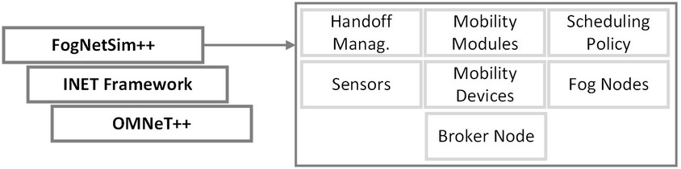

**Figure 8**

## 1.7.3 FogComputingSim:

FogComputingSim is built on top of OMNeT++, which is a powerful simulation framework for networks **[1.10.24]**.

## 1.7.3.1. Pros:

* Since it's based on OMNeT++, it inherits all the good stuff from that framework.
* You can be super flexible with it, creating your own fog computing models and algorithms.

## 1.7.3.2. Cons:

* It might not be as popular as other simulators, so the community support could be a bit limited.
* Learning OMNeT++ and using it for fog simulations might take more time and effort.

Overall, it's up to you which simulator to choose. If you're comfortable with CloudSim, go for iFogSim. If you're an NS-3 pro, FogNetSim++ is worth a shot. And if you want more flexibility, give FogComputingSim a whirl. Just keep in mind your research needs and what kind of support each simulator has. The fog computing world is always evolving, so stay in the loop with the latest updates from the fog computing research community! **[1.10.24]**

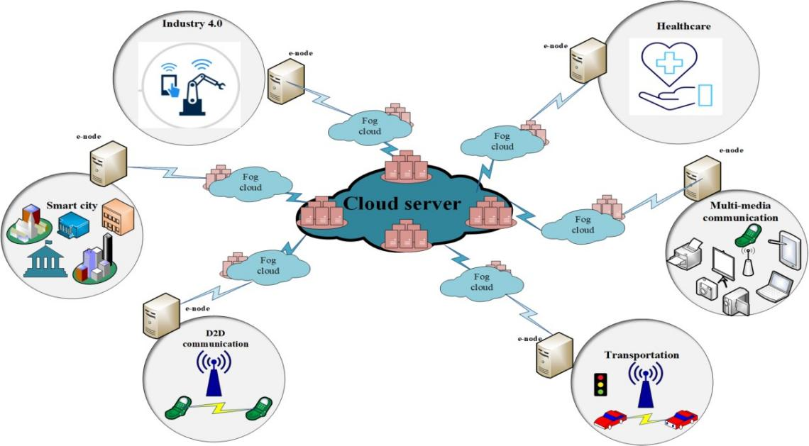

<https://bootcamp.uxdesign.cc/applications-of-fog-computing-7998d7e910d1>

**Figure 9**

# 1.8. Summary:

The summary table below distinguishes between different simulators on the basis of scalability, flexibility, cost and real-time implementation.

|  |  |  |  |  |
| --- | --- | --- | --- | --- |
| **Name of Simulators** | **Scalability** | **Flexibility** | **Cost** | **Real-time Implementation** |
| CloudSim | High | High | Low | No |
| Cloud analyst | Medium | Medium | Low | No |
| Green Cloud | High | High | Medium | No |
| DC simulators | High | Medium | Low | No |
| Emusim | High | High | Low | No |
| MR-Cloud SIM | High | Medium | Low | No |
| iFogSim | High | High | Medium | No |
| FogNetSim++ | High | High | Medium | Yes |
| SIM IC | High | Medium | Low | Yes |
| Smart SIM | Medium | High | Medium | Yes |
| NetworkCloudSim | High | High | Medium | Yes |
| iCanCloud | High | High | Low | Yes |

**1.9. Conclusion:**

On the basis of research that we have done, the conclusion says the following fog computing and cloud computing are two powerful technologies that work together to improve our digital world. Let me take an example the cloud computing is like a giant data center in the sky, which stores and process large amount of data. on the other hand, we see the fog computing is like a helper on the ground, which brings computing power closer to our devices and making things faster and more responsive. We can think cloud as a central brain and fog as a smart assistant right by your side. The cloud takes the heavy - duty tasks and long-term storage and the fog handles the immediate needs and real time processing. Being together both make our device smarter, faster, and more efficient. More about them includes that fog computing is it reduces delays and make services like smart homes, autonomous cars and real-time analytic possible. Cloud computing, on the other hand, ensures all the data is securely stored and can be accessed from anywhere, anytime **[1.10.25].**

As from the above details we observed that-

* CloudSim has high scalability, low flexibility, low cost but there is no real-time implementation.
* FogNetSim ++ has high scalability, high flexibility, medium cost and also there is real-time implementation.
* iCanCloud has high scalability, high flexibility, low cost and also there is real-time implementation.

Upcoming fog simulators will be included as future scope of the world.

**1.10. References:**

For the above research, we have utilized the ideas and information from these sites.

1.10.1. <https://www.sciencedirect.com/science/article/pii/S0167739X23000511>

1.10.2. <https://bootcamp.uxdesign.cc/challenges-in-fog-computing-c018254ab9c7>

1.10.3. <https://www.e-spincorp.com/challenges-in-implementing-fog-computing/>

1.10.4.<https://www.mdpi.com/1999-5903/12/5/89>

1.10.5. <https://www.mdpi.com/1999-5903/12/5/89>

1.10.6. <https://www.tandfonline.com/doi/abs/10.1080/09720529.2021.2016222>

1.10.7. <https://my.ece.msstate.edu/faculty/skhan/pub/A_K_2021_BC.pdf>

1.10.8. <https://www.geeksforgeeks.org/what-is-cloudsim/amp/>

1.10.9.[https://www.opensourceforu.com/2018/12/ifogsim-an-open-source-simulator-for edge-cmputing-fog-computing-and-iot/](https://www.opensourceforu.com/2018/12/ifogsim-an-open-source-simulator-for-edge-computing-fog-computing-and-iot/)

1.10.10. <https://www.researchgate.net/figure/The-Cloud-Analyst-Simulator_fig2_271155413>

1.10.11. <https://greencloud.gforge.uni.lu/>

1.10.12. [https://www.researchgate.net/figure/Overview-of-MDCsim](https://www.researchgate.net/figure/Overview-of-MDCsim-Simulator24_fig1_261436186)

[Simulator24_fig1_261436186](https://www.researchgate.net/figure/Overview-of-MDCsim-Simulator24_fig1_261436186)

1.10.13. <https://omnetpp.org/download-items/iCanCloud.html>

1.10.14. <https://ieeexplore.ieee.org/document/6123487>

1.10.15.<https://www.researchgate.net/publication/236270590_EMUSIM_An_Integrated_Emulation_and_Simulation_Environment_for_Modeling_Evaluation_and_Validation_of_Performance_of_Cloud_Computing_Applications>

1.10.16.<https://www.researchgate.net/publication/341426513_Modeling_and_Simulation_Tools_for_Fog_Computing-A_Comprehensive_Survey_from_a_Cost_Perspective>

1.10.17. <https://www.mdpi.com/1424-8220/23/7/3492>

1.10.18. <https://ieeexplore.ieee.org/document/9239644>

1.10.19. <https://ieeexplore.ieee.org/document/9239644>

1.10.20. <https://www.mdpi.com/1424-8220/23/7/3492>

1.10.21.<https://www.tandfonline.com/doi/abs/10.1080/09720529.2021.2016222?journalCode=tdmc20>

1.10.22.[https://www.sciencedirect.com/science/article/abs/pii/S1569190X20300836#:~:text=Cloud%20providers%20and%20architecture%3A%20They,their%20strategies%20with%20a%20simulator.&text=Cloud%20clients%3A%20Simulators%20can%20be,and%20study%20customer%2Drelated%20w](https://www.sciencedirect.com/science/article/abs/pii/S1569190X20300836" \l ":~:text=Cloud%20providers%20and%20architecture%3A%20They,their%20strategies%20with%20a%20simulator.&text=Cloud%20clients%3A%20Simulators%20can%20be,and%20study%20customer%2Drelated%20w)

1.10.23. <https://my.ece.msstate.edu/faculty/skhan/pub/A_K_2021_BC.pdf>

1.10.24.<https://www.tandfonline.com/doi/abs/10.1080/09720529.2021.2016222?journalCode=tdmc20>

1.10.25.[https://www.ingentaconnect.com/content/ben/rascs/2022/00000015/00000003/art00004#:~:text=Conclusion%3A%20There%20are%20many%20fog,computing%20are%20iFogSim%20and%20EmuFog.](https://www.ingentaconnect.com/content/ben/rascs/2022/00000015/00000003/art00004" \l ":~:text=Conclusion%3A%20There%20are%20many%20fog,computing%20are%20iFogSim%20and%20EmuFog.)